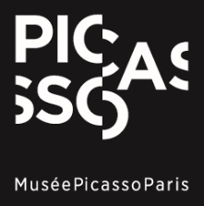
PRESS RELEASE
Paris, 3 December 2025

Henry Taylor. Where thoughts provoke

From 8 April 2025 to 6 September 2026, the Musée national Picasso-Paris will present Henry Taylor.Where thoughts provoke, an exhibition devoted to one of the most significant figures in contemporary American painting. This exhibition, designed in collaboration with the artist himself, spans his entire artistic career while continuing the museum’s exploration of Pablo Picasso’s reception on the American scene. It follows exhibitions dedicated to Faith Ringgold (2023), Jackson Pollock (2024) and Philip Guston (2025), and precedes the major retrospective devoted to the Harlem Renaissance movement (spring 2027).

The exhibition, laid out across two floors and thirteen rooms, brings together approximately one hundred works–including painting, sculpture, and installation–through which Henry Taylor explores the richness and complexity of the human experience. Whether portraying friends, loved ones, unnamed passersby, or well-known figures, Taylor’s compositions offer a multilayered vision of contemporary life. His work is direct and deeply resonant: he weaves visual narratives that speak to individual journeys and broader social currents, blending personal experience, collective memory, and thoughtful dialogues with art history. References to inspiring figures such as David Hammons, Philip Guston, and Pablo Picasso highlight Taylor’s dynamic engagement with the past as he reimagines it for the present.
Henry Taylor has been the subject of numerous exhibitions in the United States and abroad, including a major retrospective at the Museum of Contemporary Art, Los Angeles in 2022 that later traveled to the Whitney Museum of American Art, New York in 2023. His works feature in leading public collections, notably at the Studio Museum in Harlem, New York, The Metropolitan Museum, New York, and the Museum of Modern Art, New York. This exhibition at the Musée national Picasso-Paris is the artist's first survey exhibition in France.

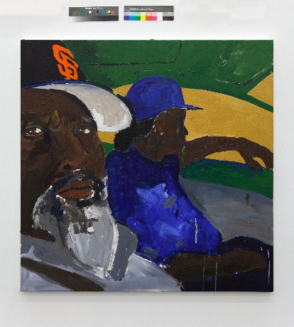

Henry Taylor,
LOOK, 2015. Coll. Part.
Photo Sam Kahn
© Henry Taylor
Courtesy the artist and Hauser & Wirth

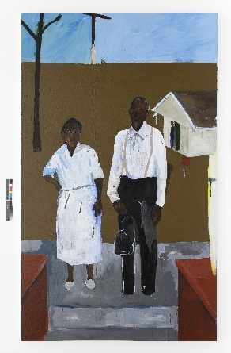
Henry Taylor,
Queen & King, 2013. Marciano Art Foundation, Los Angeles.
Photo Sam Kahn
© Henry Taylor
Courtesy the artist and Hauser & Wirth

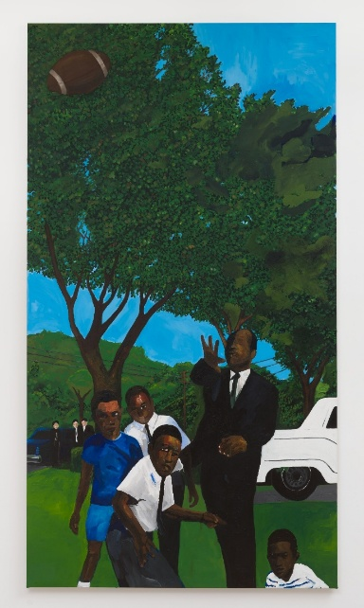

Henry Taylor,
Untitled, 2016-22. Coll. Part.
Photo Jeff McLane
© Henry Taylor
Courtesy the artist and Hauser & Wirth

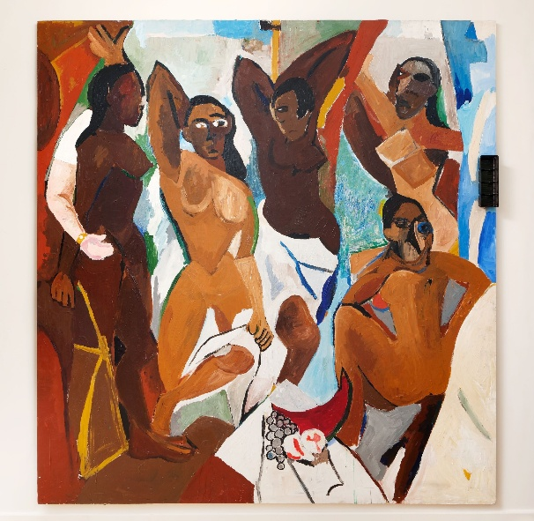
Henry Taylor
From Congo to the Capital, and black again, 2007
Photo Aurélien Mole
© Henry Taylor
Courtesy the artist and Hauser & Wirth

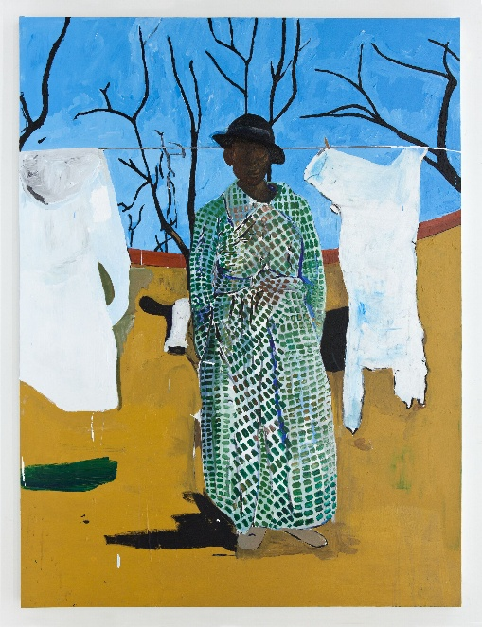
Henry Taylor
Mary had a little… (that aint no lamb), 2013
Photo Sam Kahn
© Henry Taylor
Courtesy the artist and Hauser & Wirth

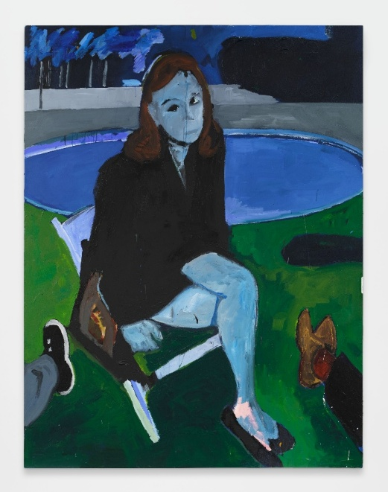
Henry Taylor
WHO KNEW I WOULD PAINT YOU BLUE, 2025
Photo Paul Salveson
© Henry Taylor
Courtesy the artist and Hauser & Wirth

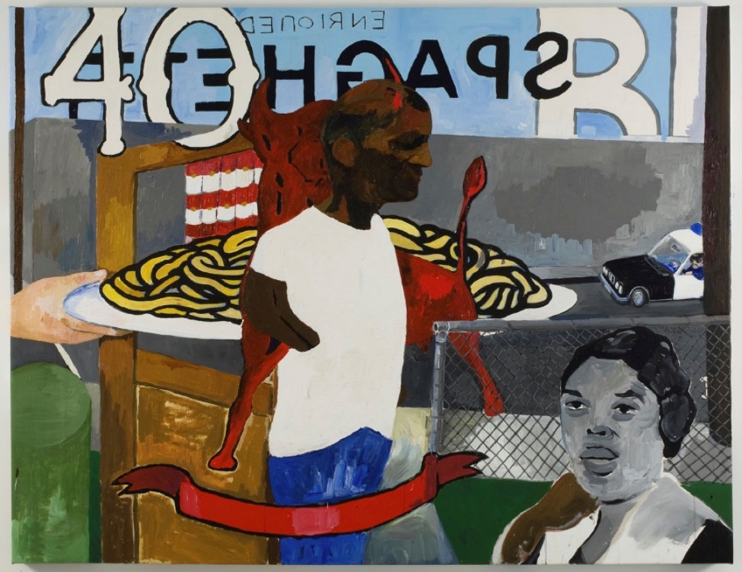

Henry Taylor
Served up, 2009
© Henry Taylor
Courtesy the artist and Hauser & Wirth

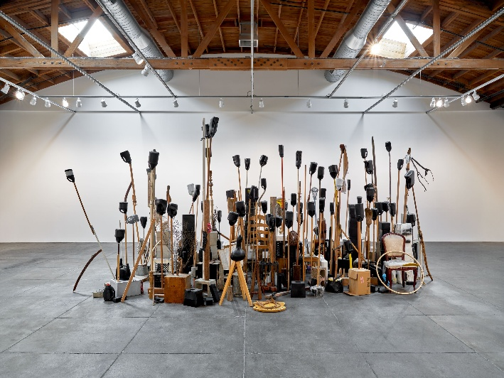
Henry Taylor
It’s like a jungle, 2011
Photo Keith Lubow
© Henry Taylor
Courtesy the artist and Hauser & Wirth

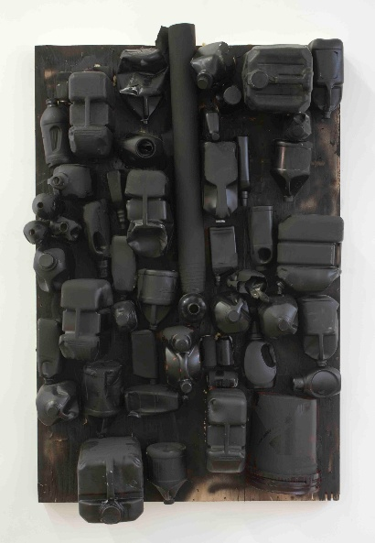

Henry Taylor
Untitled (Wall Sculpture), 2012
Photo Adam Reich
© Henry Taylor
Courtesy the artist and Hauser & Wirth

Currently at the Musée national Picasso-Paris

- Permanent collection

- Philip Guston. The irony of history.
Until 2026, March the 1st

- Raymond Pettibon. Underground
Until 2026, March the 1st

